**Mc Gabriel Fernandez  
Nima Nejad  
Chance Bellon**

**Spec Checker**

**Test Procedure**

***Revision History***

| **Authors** | **Description of Change** | **Sections** | **Rev** | **Date** |
| --- | --- | --- | --- | --- |
| Mc Gabriel Fernandez | Added test cases |  |  | 12/4/2022 |
| Mc Gabriel Fernandez | Tested test cases |  |  | 12/6/2022 |

**Table of Contents**

1 Team Description 4

2 Introduction 4

2.1 Identification 4

3 Test Procedures 4

3.1 Test Case 1 5

3.2 Test Case 2 7

3.3 Test Case 3 9

3.4 Test Case 4 11

3.5 Test Case 5 13

3.6 Test Case 6 15

3.7 Test Case 7 17

3.8 Test Case 8 18

3.9 Test Case 9 20

4 Verification Cross Reference Matrix 22

# Team Description

| **Team Member Name** | **Email Address** |
| --- | --- |
| Mc Gabriel Fernandez | mcgabrielf@csu.fullerton.edu |
| Nima Nejad | nimanejad2012@gmail.com |
| Chance Bellon | chancebellon01@gmail.com |
|  |  |
|  |  |
|  |  |

# Introduction

Put introduction text here.

## Identification

| **Requirement Document Tested:** | 12/6/2022 |
| --- | --- |
| **Requirement Document Revision:** |  |
| **Revision Release Date:** |  |

# Test Procedures

## Test Case 1

Description: User knows what to search for

Precondition:

1) At Home Page

2) Click on Search Bar

| **Step Number** | **Action** | **System Response** | **Requirement Tested**  **(if applicable)** |
| --- | --- | --- | --- |
| 1 | Enter game input: Example: The Callisto Protocol | Dropdown of games close to search input |  |
| 2 | User clicks on game: The Callisto Protocol | Output minimum/recommended requirements for game, “The Callisto Protocol” |  |
| 3 |  |  |  |
| 4 |  |  |  |
| 5 |  |  |  |
| 6 |  |  |  |

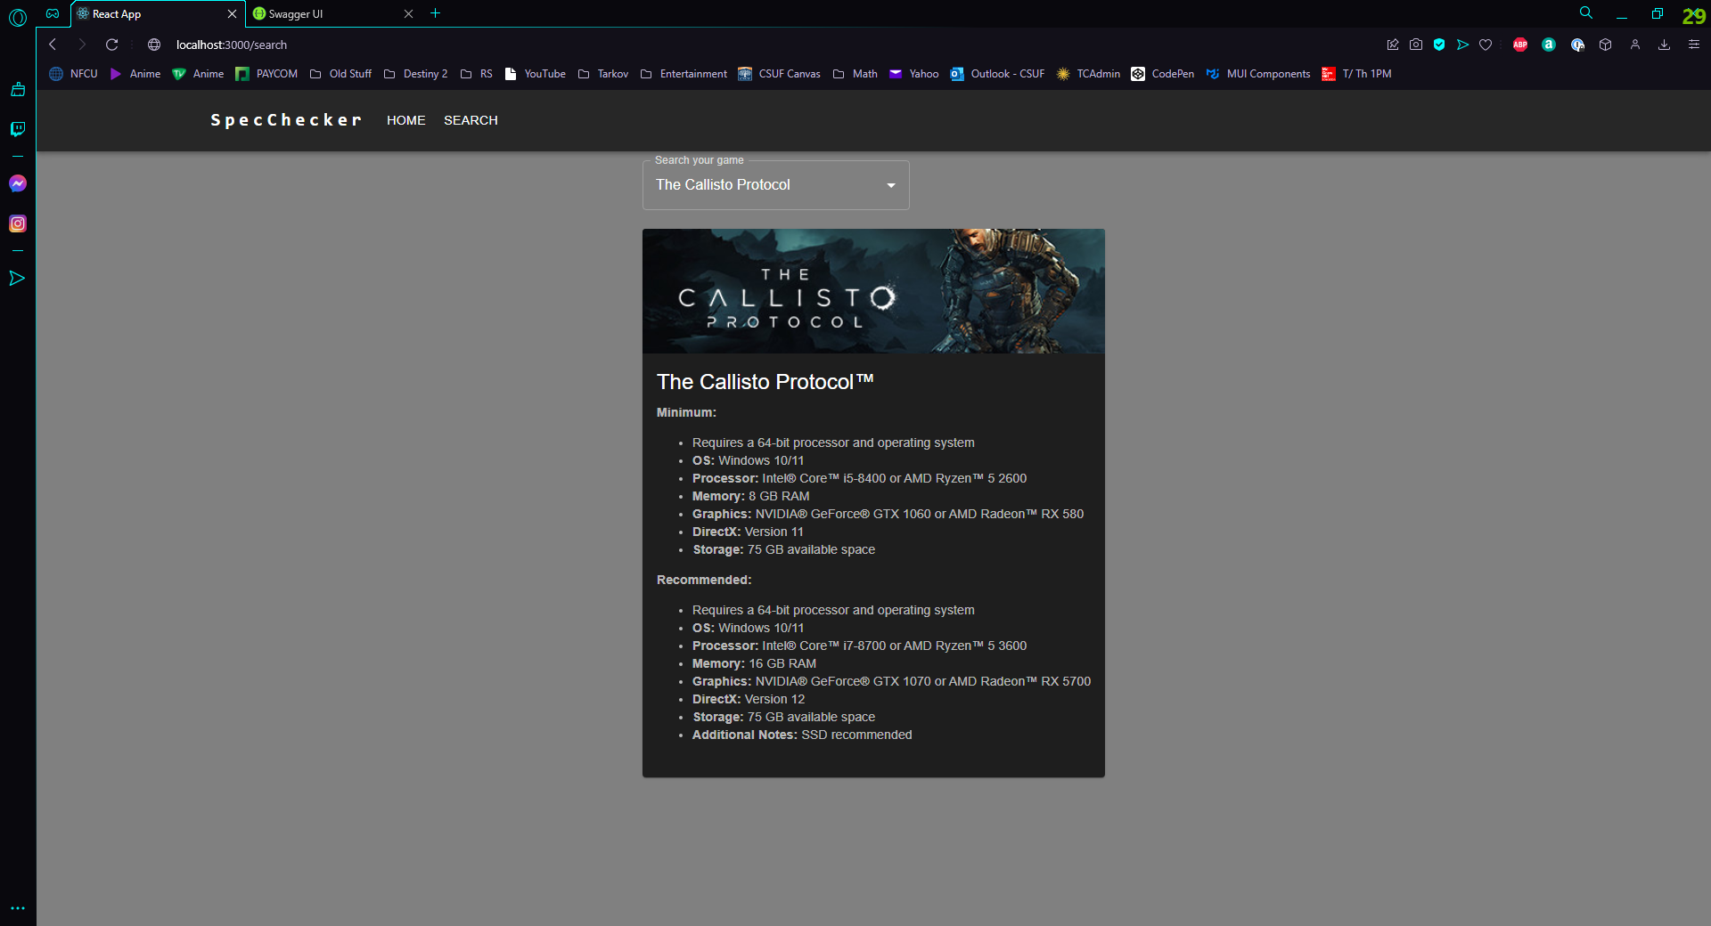

## Test Case 2

Description: User search keywords, without typing the full game name

Precondition:

1) At Home Page

2) Click on Search Bar

| **Step Number** | **Action** | **System Response** | **Requirement Tested**  **(if applicable)** |
| --- | --- | --- | --- |
| 1 | User inputs part of game name: Example: “World”, while looking for game name, “New World” | Dropdown from search bar with list of games closest to the game, “World” |  |
| 2 | User clicks on game | Output of minimum/recommended requirements |  |
| 3 |  |  |  |
| 4 |  |  |  |
| 5 |  |  |  |
| 6 |  |  |  |

## 

## Test Case 3

Description: Back to back searches

Precondition:

1) At Home Page

2) Click on Search Bar

| **Step Number** | **Action** | **System Response** | **Requirement Tested**  **(if applicable)** |
| --- | --- | --- | --- |
| 1 | User inputs another game title: Example: Dota 2 | Dropdown list appears under search bar with a list of games closest to “Dota 2” |  |
| 2 | User clicks on game from dropdown | Output minimum and recommended requirements for Dota 2 |  |
| 3 | User deletes previous search from search bar and user types Sims 4 | Dropdown list appears under search bar with a list of games closest to Sims 4 |  |
| 4 | User clicks on game, Sims 4, from dropdown | Output minimum and recommended requirements for Sims 4 |  |
| 5 |  |  |  |
| 6 |  |  |  |



## Test Case 4

Description: User inputs gibberish

Precondition:

1) At Home Page

2) Click on Search Bar

| **Step Number** | **Action** | **System Response** | **Requirement Tested**  **(if applicable)** |
| --- | --- | --- | --- |
| 1 | User types in random characters: Example: “asdfakdhaklshf” | System outputs: “No options” |  |
| 2 |  |  |  |
| 3 |  |  |  |
| 4 |  |  |  |
| 5 |  |  |  |
| 6 |  |  |  |

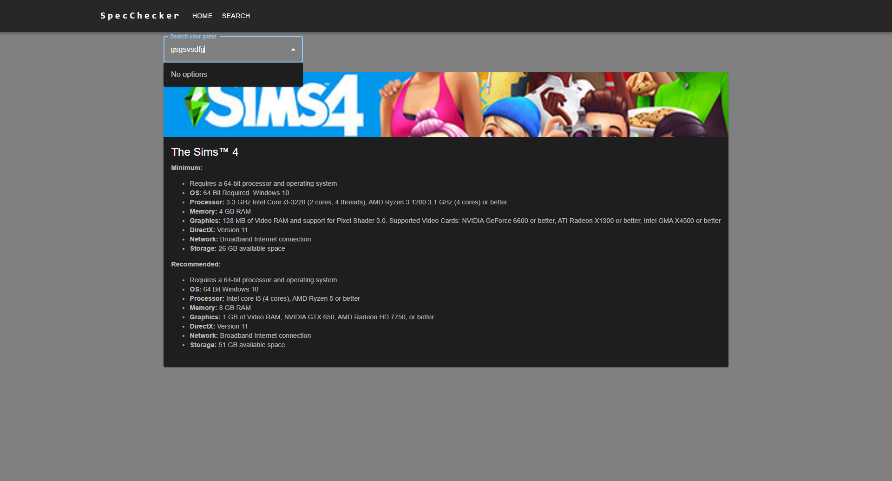

## Test Case 5

Description: Click on logo “Spec Checker” to go to home page

Precondition:

1) Current page can be anywhere on website

| **Step Number** | **Action** | **System Response** | **Requirement Tested**  **(if applicable)** |
| --- | --- | --- | --- |
| 1 | User clicks on “Spec Checker” logo | Transfers user to home page |  |
| 2 |  |  |  |
| 3 |  |  |  |
| 4 |  |  |  |
| 5 |  |  |  |
| 6 |  |  |  |



## Test Case 6

Description: Click on video game from dropdown

Precondition:

1) Game input already set on search bar

| **Step Number** | **Action** | **System Response** | **Requirement Tested**  **(if applicable)** |
| --- | --- | --- | --- |
| 1 | Click on desired game with game input set | Output minimum and recommended requirements with given game |  |
| 2 |  |  |  |
| 3 |  |  |  |
| 4 |  |  |  |
| 5 |  |  |  |
| 6 |  |  |  |



## Test Case 7

Description: User inputs foreign language (Chinese, Korean, Japanese, German, Deutch)

Precondition:

1) At Home Page

2) Click on Search Bar

| **Step Number** | **Action** | **System Response** | **Requirement Tested**  **(if applicable)** |
| --- | --- | --- | --- |
| 1 | User inputs foreign language | Dropdown list appears with game close to the game title | Input must be exact as the game title |
| 2 |  |  |  |
| 3 |  |  |  |
| 4 |  |  |  |
| 5 |  |  |  |
| 6 |  |  |  |

## Test Case 8

Description: Games with missing info (minimum/recommended requirements)

Precondition:

1) Game searched

2) Must already show output of minimum and recommended requirements

| **Step Number** | **Action** | **System Response** | **Requirement Tested**  **(if applicable)** |
| --- | --- | --- | --- |
| 1 | No action needed | Game ignores empty specifications and outputs what’s listed and available |  |
| 2 |  |  |  |
| 3 |  |  |  |
| 4 |  |  |  |
| 5 |  |  |  |
| 6 |  |  |  |

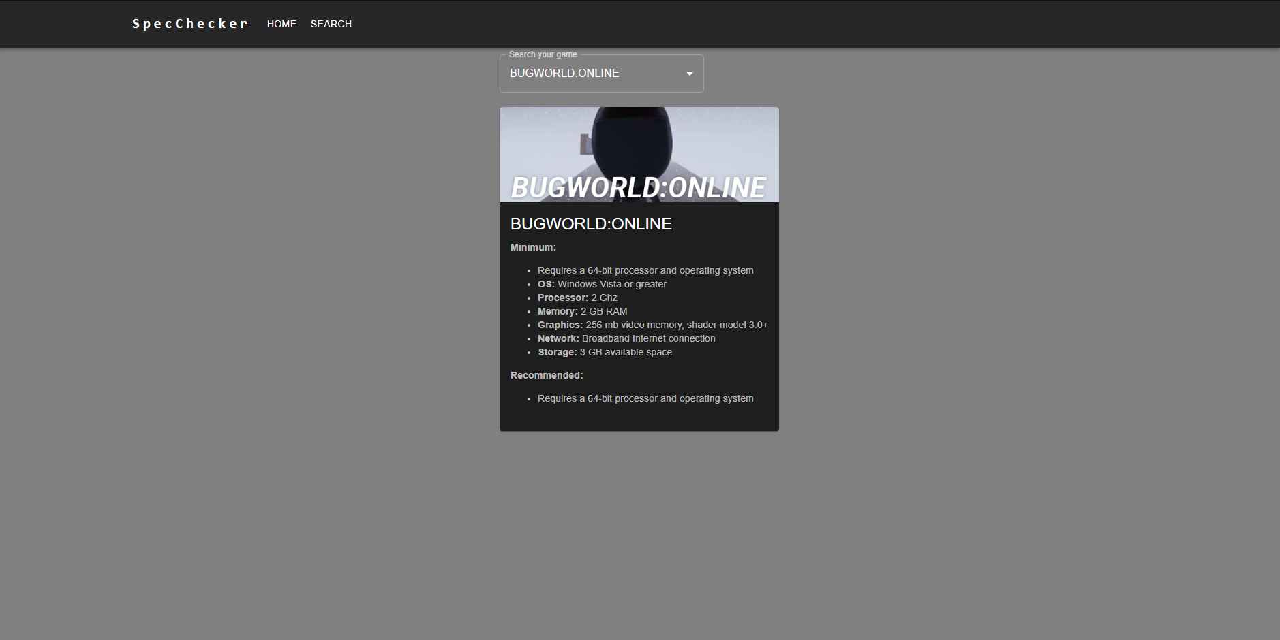

## Test Case 9

Description: Expansion packs, Downloadable Contents (DLC)

Precondition:

1) At Home Page

2) Click on Search Bar

3) User input is a Downloadable Content (DLC)/Expansion pack

| **Step Number** | **Action** | **System Response** | **Requirement Tested**  **(if applicable)** |
| --- | --- | --- | --- |
| 1 | User inputs a DLC: Example:  Call of Duty: Modern Warfare 3 Chaos Pack | Outputs minimum and recommended system requirements to run DLC/Expansion pack |  |
| 2 |  |  |  |
| 3 |  |  |  |
| 4 |  |  |  |
| 5 |  |  |  |
| 6 |  |  |  |

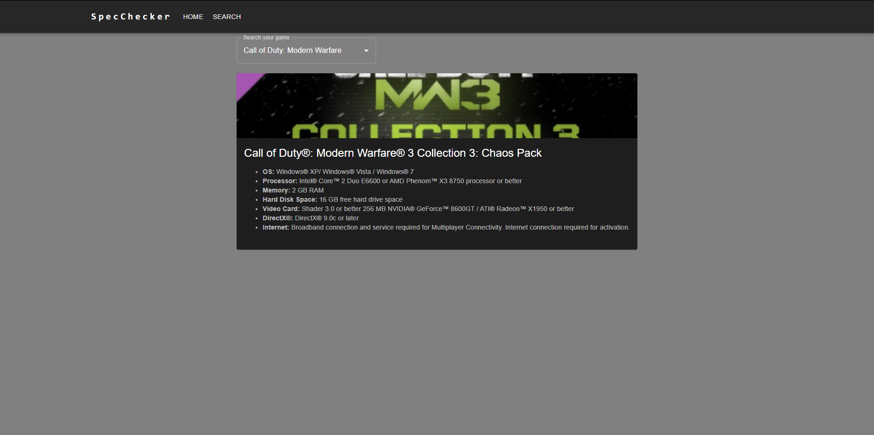

# Verification Cross Reference Matrix

| **Requirement Identifier** | **Where Tested** |
| --- | --- |
|  | VS Community |
|  | VS Code |
|  |  |
|  |  |
|  |  |
|  |  |